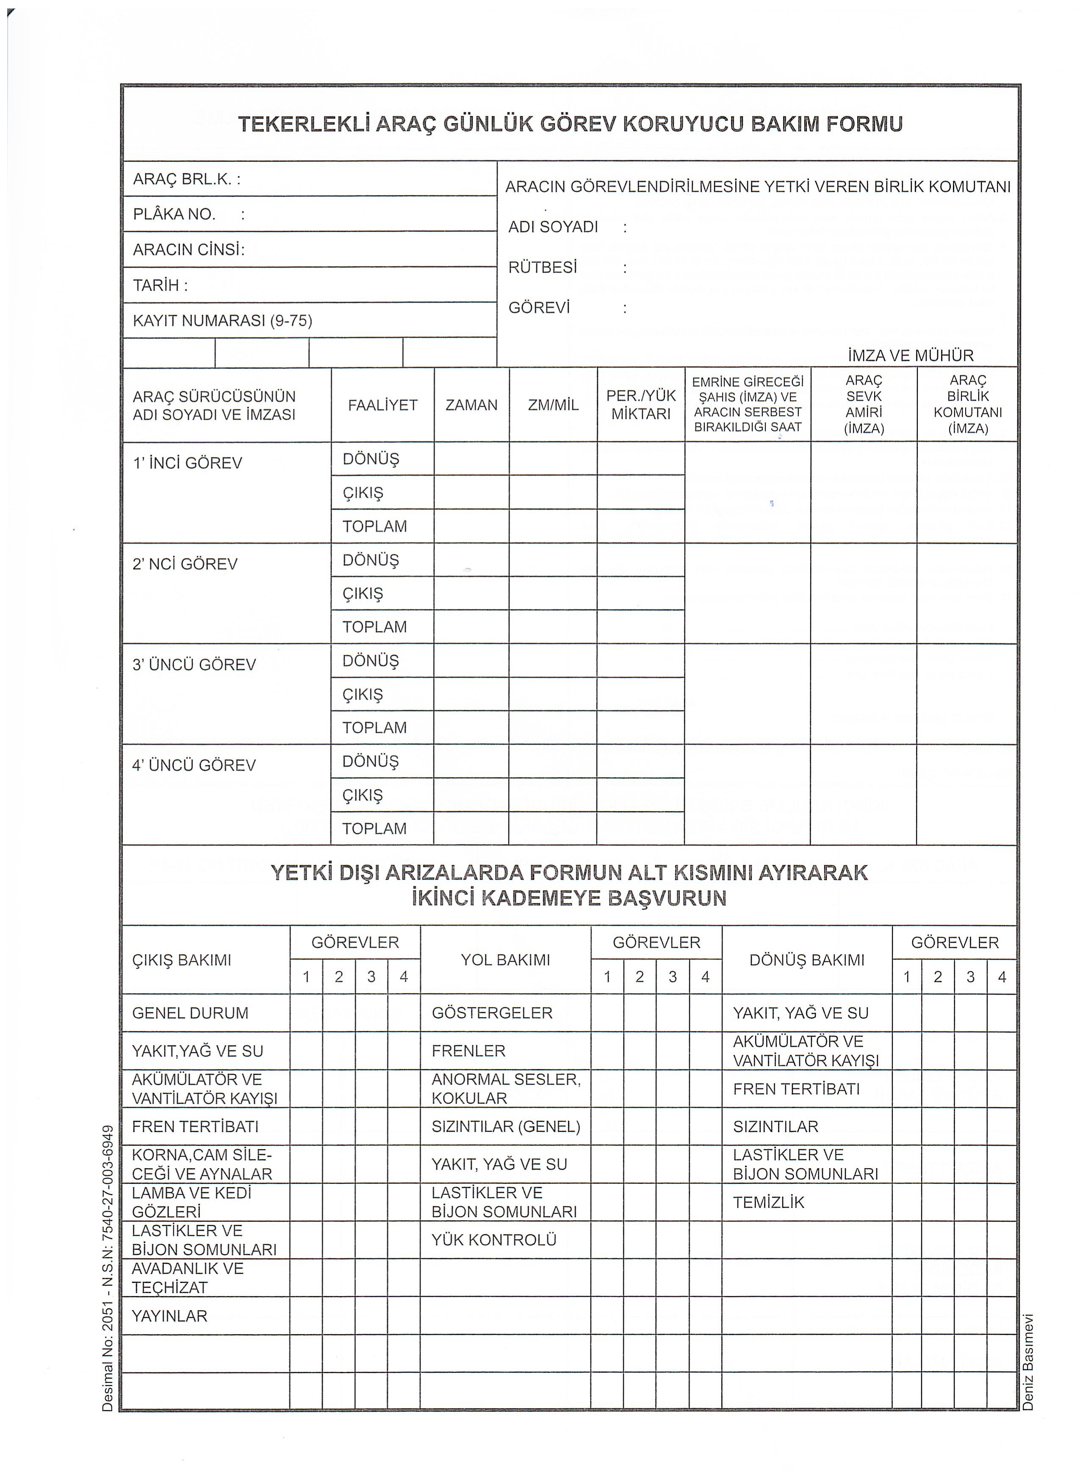
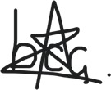
✓
✓
✓
✓
✓
✓
✓
✓
✓
✓
✓
✓
✓
✓
✓
✓
✓
✓
✓
✓
✓
ORDUEVLERİ MÜDÜRLÜĞÜ
514373
RENAULT KANGOO
……/……/2026
4
Buğra Can Çelik
✓

