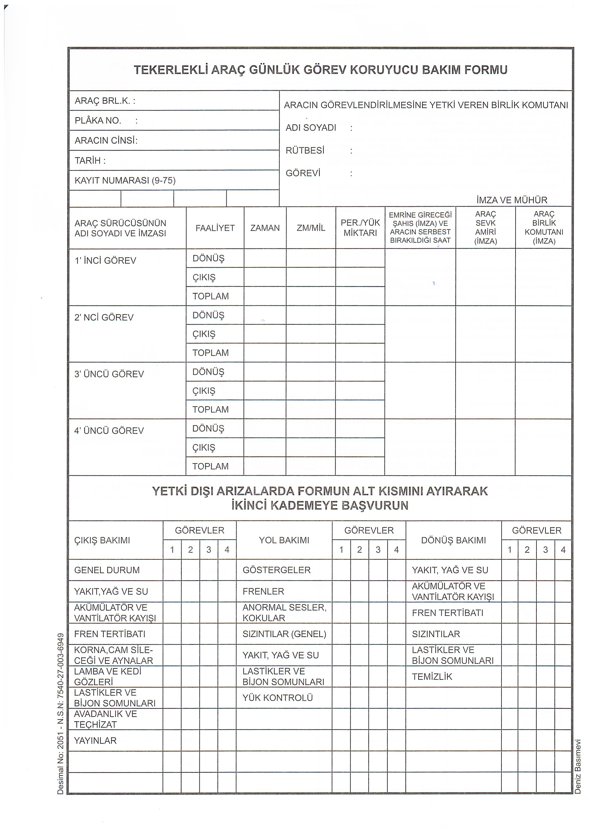
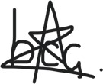
ORDUEVLERİ MÜDÜRLÜĞÜ
514378
RENAULT TRAFİC
……/……/2026
Buğra Can Çelik
✓

✓
✓
✓
✓
✓
✓
✓
✓
✓
✓
✓
✓
✓
✓
✓
✓
✓
✓
✓
✓
✓

